TRAFFIC SPEED ANALYSIS FOR FORBES RECONSTRUCTION PROJECT

**Introduction**

The Forbes Avenue reconstruction project focuses on the road between S Craig Street and Margaret Morrison Street that is being reconstructed from 4 lanes (2 lanes in each direction) to 3 lanes which includes one lane in each direction along with a center turn lane. It will also include 2 pedestrians crossing and a dedicated bike lane.

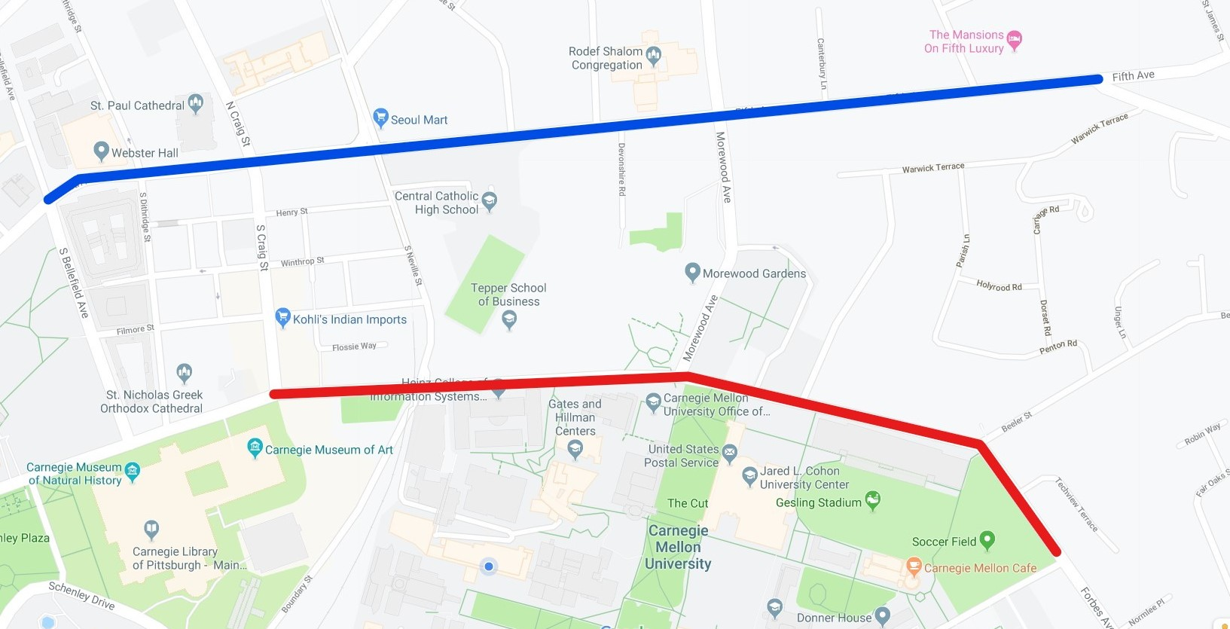

Figure 1: Map of Forbes Avenue(Red) and Fifth Avenue(Blue)

The impact assessment of this road is divided into three different stages of construction – Before, during and after. The period and road condition for above mentioned stages are given in table 1.

|  |  |  |
| --- | --- | --- |
| **STAGE** | **TIME** | **ROAD CONFIGURATION** |
| BEFORE | 1/1/2017- 3/7/2018 | Four Lanes |
| DURING | 3/7/2018- 5/21/2018 | Westbound goes from one to two lanes Eastbound is two Lanes |
| 5/21/2018-8/14/2018 | Four lanes (Two Lanes in each direction) |
| 8/14/2018-3/22/2019 | Eastbound is one lane and Westbound is two lanes along with temporary lights |
| 3/22/2019-6/4/2019 | Four lanes (Two Lanes in each direction) along with permanent lights |
| AFTER | 8/1/2019 onwards | Three lanes including a center turn lane |

Table 1: Timeline for different construction.

The fields of interest of this project are traffic speed, bus counts, pedestrian counts, bus ridership, incident, noise and air quality. This report focuses on the traffic speed and incident aspect of the project. The final goal of this project is to analyze various data in the above-mentioned fields of interest in order to achieve a configuration that which is friendly as well as safe for all its users be it pedestrians or bicyclist.

**Data**

To analyze the traffic speed, we have used the data provided by INRIX. INRIX Traffic Service provides information on road speed, both current and predicted. Road sensors and cameras are used to provide information of current flow. Our data set varies from January 01,2017 through June 04,2019 between 05:00 and 22:00 averaged over 5 minutes. Traffic Message Channel (TMC) gives traffic and travel information to drivers. Every road has a different TMC code. The TMC data set tells us about the road, intersection and direction based on the TMC code.

In order to analyze the incident that took place on Forbes Avenue, we used the Allegheny County Crash Data from Western Pennsylvania Regional Data Center(WPRDC) provided by the Pennsylvania Department of Transportation (PennDOT). This included crashes from the year 2004 to 2017.

**Method**

**1. Speed Analysis**

The data between S. Craig St. and Margaret Morrison St. on Forbes Avenue was taken from the TMC Identification data along with the data between S. Bellefield St. and Wilkins on Fifth Avenue. The reason behind including Fifth Avenue in our analysis is to get a bigger picture and know if reconstruction of Forbes Avenue is affecting the road just adjacent to it. The INRIX data set have three levels of confidence:

* Score 10 for historic data
* Score 20 for mixture of historic and real time data
* Score 30 for real time data

We have filtered out all the data having confidence score less than 30 from the speed data to get only real time data. We then merged the speed data with TMC identification data by doing an inner join. From the resultant data set, we split the data into Forbes and Fifth. The data set for Forbes and Fifth was again split based on direction i.e. eastbound and westbound.

The data set was then divided into the period of different construction dates as per Table 1 and their average speed as plotted against the hour of the day. To have a better picture, we focused only on the peak hours. The morning peak hour was defined between 7:00AM - 10:00AM and evening peak hours was 3:00PM-7:00PM. The data was then split into weekdays and weekends. We compared average speed for different hours of the day for two lanes and one lane. We proceeded by directly comparing the speed before and during construction on Forbes.

To ensure that our results were not affected by the road condition during different seasons, we split the data into the different seasons of the year keeping in mind whether university was in session. The duration of each season is given in table 2.

Table 2 : Date for different seasons.

|  |  |
| --- | --- |
| SEASON | DATES |
| Spring | 3/1-5/15 |
| Summer | 5/15-9/1 |
| Fall | 9/1-11/30 |
| Winter | 12/1-12/20 and 1/20-3/1 |

**2.Incident Analysis**

The incident data set was then analyzed by looking at the type of accidents as well as the count of accident that took place in the year 2015, 2016 and 2017 on Forbes Avenue between S Craig St. and Margaret Morrison St. A correlation between reasons behind the accident was done to know how strongly one reason affected the other. We also did a cost analysis that gives the annual cost of accidents that took place on Forbes avenue. The total societal cost was then divided into different compositions as per the figure 2.

. 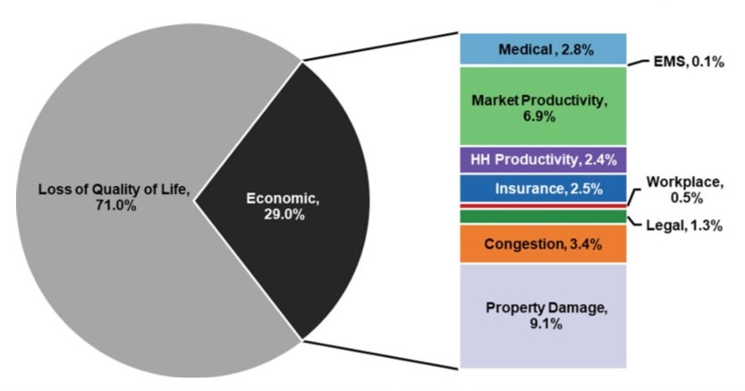

Figure 2:Composition of Societal Cost

**Result**

**1.Speed**

We began our analysis by looking at the variation of speed on Forbes avenue as well as on Fifth Avenue with respect to different during construction periods. Clear differences were not observed so we looked at peak hours. It was observed that Forbes Eastbound shows a decrease in speed from 17mph to 15 mph during evening peak hours when it is changed from two lanes to one lane. The data was then split into weekdays and weekends and it was again observed as shown in figure 3 that Forbes Eastbound undergoes a decrease in speed during the time it was one lane with permanent lights.

Figure 3: Variation of speed on Forbes Avenue in Eastbound Direction. 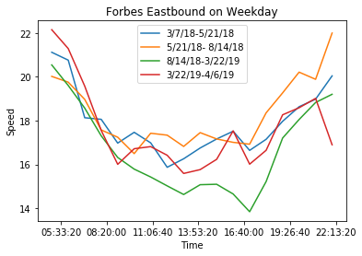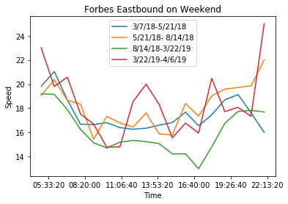

Having these results, we moved on with comparing speed on Forbes Avenue for one lane and two lanes, results of which can be seen in figure 4. There was no such difference in Forbes westbound lane but eastbound clearly show that there is a decrease in speed when it is changed from two lanes to one lane.

Figure 4: Comparison of speed for One Lane and Two Lanes each Direction 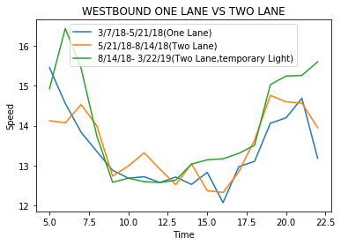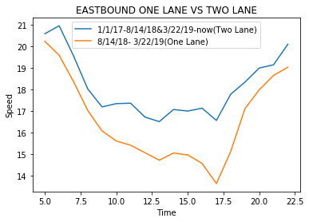

When we compared before and during construction scenario similar result was seen on Forbes Eastbound. It was also observed that when there was construction going on Forbes avenue there is increase in average speed in Fifth Avenue as compared to when there was no construction.

Figure 5: Comparison of speed on Fifth Avenue before and during construction on Forbes Avenue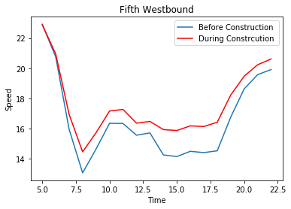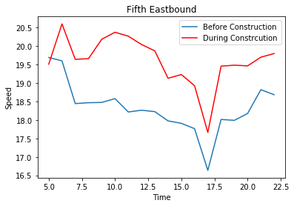

When we compared the speed for different seasons during office peak hours in order to get a clearer picture, it was observed that Forbes eastbound has a low average speed in fall during evening peak hour as shown in figure 6 but the decrease in average speed was approximately 1mph.

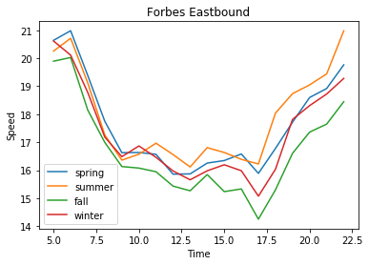

Figure 6:Comparison of speed during different seasons on Forbes Eastbound

**2.Incidents**

The result of the correlation is given in Figure 7 which shows that icy road condition is important reason for accident and there hasn’t been any accident because of running of stop sign or fatigue. It was also found that most of the accidents were collision type.

Figure 7: Correlation between different reason of accident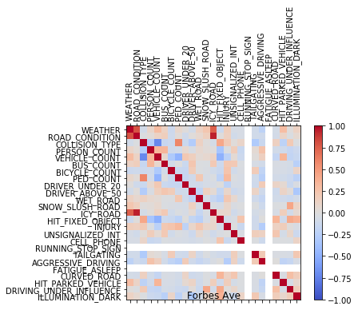

From Accident Analysis and Prevention paper by Corey and Prof Hendrickson, we know that the cost of an accident in the 2010 was $154,000. From the year 2010 to year 2017 there has been an inflation of 12.41% in USD, hence the cost of a crash in year 2017 can be approximately $173,110. The total annual cost of accidents is given in table 3. This total annual societal cost was divided into different composition as per figure 2 and the result is displayed in table 4.

Table 3: Total annual societal cost of accidents

|  |  |  |
| --- | --- | --- |
| Year | Number of Accidents | Cost |
| 2017 | 4 | $692,452 |
| 2016 | 2 | $339,004 |
| 2015 | 4 | $669,564 |

Table 4: Composition of total annual societal cost.

|  |  |  |  |  |  |  |  |  |  |
| --- | --- | --- | --- | --- | --- | --- | --- | --- | --- |
| Year | Loss of quality of life | Medical | Market and HH productivity | Property Damage | EMS | Insurance | Workplace | legal | Congestion |
| 2017 | $491,640 | $19,39 | $64,400 | $63,000 | $690 | $17,310 | $3,460 | $9,000 | $23,540 |
| 2016 | $339,000 | $9,490 | $31,500 | $30,850 | $340 | $8,470 | $1,700 | $4,407 | $11,560 |
| 2015 | $475,390 | $18,750 | $46,500 | $62,270 | $670 | $16,740 | $3,350 | $8,704 | $22,770 |

**Conclusion**

The change in average speed during different construction stages as defined in table 1 varies from 1mph to 3mph and evident change was only seen on Forbes Avenue in Eastbound direction. It was also observed that there was an increase in average traffic speed when there was construction going on Forbes Avenue. We were not able to comprehend the reason behind this result. We can also conclude that traffic speed on Forbes is affected by whether university is in session. The average speed on Forbes Avenue was highest during the holiday break.

Though we don't have the incident data for the year 2018, as most of the accidents are collision type we can expect a decrease in accident because of the provision of center turn lane between the two lanes. We can also hope for a decrease in accidents involving bicyclists.

Keeping in frame all the aspects by which traffic speed can be affected, it is safe to say that traffic speed is not comprised when we are reconstructing road for better configuration. We also hope that once we have the data for after construction, we don't see a change in speed when two lanes in each direction is changed to one lane each direction.

The result of this study can be used for reconstruction of road from four lanes(two lanes in each direction) to two lanes( One lane in each direction) as per the requirement of the road and inclusion of a bicyclist lane for safety and convenience purposes.